REPORTED SPEECH
First I'd like to draw your attention that once the reporting verb (e.g. SAY, TELL) is in the present simple [She says] or the present perfect [He has told us] or the future simple tense [They will tell you], there's no change of tense at all.
Example:
She says, "John prefers tea"
She has told us that John prefers tea.
Yet, once the reporting verb is in the past (e.g. SAID, TOLD, REPORTED? etc), many changes occur depending of course on the tense used in the moment of speaking.
- In direct speech the reporter repeats the original words of the speaker:
Leila said, "The cat has broken the vase."
- In the indirect (reported) speech the reporter gives the exact meaning of the speaker's utterance without necessarily repeating the exact words of the speaker:
Leila said (that) the cat had broken the vase.

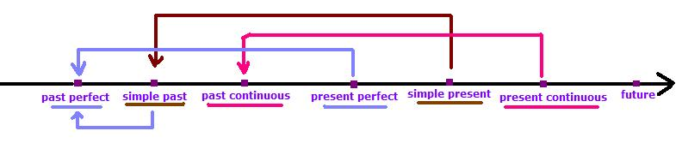

Tense Changes
Direct Speech | Indirect Speech
do /does | did
am / is / are doing | was / were doing
have / has done | had done
did | had done
shall do | should do
will do | would do
can do | could do
must do | had to do
needn't do | didn't have/need to do
should | should
would | would
could | could

Some other expressions such as the adverbs of time and place also change :
Direct Speech | Indirect Speech
here | there
now / at the moment | then / at once
this | that
yesterday | the day before (or) the previous day
the day before yesterday | two days before
last week/month/year/Monday etc. | the previous week/month/year/Monday etc.
tomorrow | the day after (or) the following day
the day after tomorrow | in two days time
next week/month/year/February/Sunday etc. | The following week/month/year/February/Sunday etc.
three years ago | three years before
today / tonight | that day / that night

Look at these examples:
- John said, "I am going to look for a larger flat"
- John said that he was going to look for a larger flat.
- Sue said, "I have done my homework."
- Sue said that she had done her homework.
This is also true with modal verbs (will, can, must, may, etc). Our emphasis should go to them and keep the main verbs untouched.
- John said, "The pupils may go home earlier this afternoon"
- John said that the pupils might go home earlier that afternoon.
- The teacher said, "The best students will be rewarded."
- The teacher said that the best students would be rewarded.
Illustrations:
